Time logging system “Loggy”
Software Architecture Description
Tautvydas Skardžius
tautvydas.skardzius@mif.stud.vu.lt
Version 2
2020-12-07

Version History

Version | Date | Author | Comments
1 | 2020-11-24 | Tautvydas Skardžius | Initial version
2 | 2020-12-07 | Tautvydas Skardžius | Revised the document up to functional view, added additional viewpoints.

Table of Contents
1. Version History 2
2. Table of Contents 3
3. Introduction 4
3.1 Purpose and Scope 4
3.2 Audience 4
3.3 Status 5
3.4 Architectural Design Approach 5
4. Glossary 6
5. System Stakeholders and Requirements 7
5.1 Stakeholders 7
5.2 Overview of Requirements 8
5.3 System Scenarios 9
6. Architectural Forces 12
6.1 Goals 12
6.2 Constraints 12
6.3 Architectural Principles 12
7. Architectural Views 14
7.1 Context View 14
7.2 Functional View 14
7.3 Information View 17
7.4 Concurrency View 20
7.5 Deployment View 22
7.6 Development View 24
7.7 Operational View 27

Introduction

Purpose and Scope

What is this document for - primarily this is to document the architecture for the stakeholders, to ensure that it meets their goals and concerns and that the proposed architecture is correct, complete and fit for purpose.

Project context – currently, the company employees register their hours manually and send the spreadsheets to their managers, who, after they have already approved it, sends the spreadsheets to the accountants.
Project goals & objectives:
- Automate hour registration process
- Have employee hour registration data aggregated in one place

Project scope:
- A way for employees to log time spend working in a project, taken vacations, work on a non-project related matters.
- A solution for the accountant to retrieve all the time registrations by the end of the month.
- A way for managers to approve/reject on employees timesheets.

Scope exclusions:
- This software is developed for one tenant only.

Audience
- CEO
- Project manager
- Developers
- Maintainers
- Testers
- Employees
- Accountants
- Managers
- Administrators

Status

It’s the architectural description’s second version. The description contains 7 different viewpoints.

Architectural Design Approach

This document if written by following 7 viewpoints. These viewpoints can be found in the following pages in the document.

Glossary

Term | Definition
Term | Definition of the term
Project dimension | Rows in which employees can log time
Subordinate | A relationship from manager’s point of view to the employee they manage.

System Stakeholders and Requirements

Stakeholders

Stakeholders:
- Acquirers:
  - CEO
    - Interest - will pay for the system
    - Needs:
      - Automate employee’s time registration process
      - Have employee’s time registration data aggregated in one place
      - System should be relatively cheap to run & maintain
    - Concerns:
      - System’s development will be expensive
      - System’s maintenance will be expensive
      - System will take long to develop
- Assessors/Communicators:
  - Project manager
    - Interest – will be responsible for the creation of the system
    - Needs:
    - Concerns:
      - Created system will not satisfy stakeholder’s needs
- Developers:
  - Interest – will develop the system
  - Needs:
    - Automated CI & CD pipeline
    - Non-legacy technology stack
    - Have external logs aggregator
  - Concerns:
    - Tight budget
    - Tight schedule
    - Scope creep
- Maintainers:
  - Interest – will maintain the system
  - Needs:
    - Good project documentation
    - Automated CI & CD pipeline
    - Have external logs aggregator
  - Concerns:
    - Project will have no/poor documentation
    - Project will be “hacked up” & not been developed following the best practises
- Testers:
  - Interest – will test the system
  - Needs:
    - At least one test environment
  - Concerns:
    - There will be no test environments
- Users:
  - Employees
    - Interest - need to register hours, so the accountants know what salary to pay
    - Needs (Refer to 5.2. section)
    - Concerns
  - Accountants
    - Interest - need logged hours in this system in order to generate payslips
    - Needs (Refer to 5.2. section)
    - Concerns
  - Managers
    - Interest - will be responsible for subordinate’s time logging activities, will approve/reject them.
    - Needs (Refer to 5.2. section)
    - Concerns
  - Administrators
    - Interest - will be responsible for managing systems’ internal configuration
    - Needs (Refer to 5.2. section)
    - Concerns

Overview of Requirements
Functional requirements:
Reference | Requirement Description
 | As an employee, register time in a specific group for a specific day (create time registration, e.g. 8 hours on 24th of November for paid vacation).
 | As an employee, edit/remove existing time registration
 | As an employee, comment on a specific time registration
 | As an employee, remove your own comment from time registration
 | As an employee, confirm time registrations for a specific month
 | As an employee, see registered hours, that exceed daily limit, in an different way (marked red)
 | As an employee, see public holiday days in a different way (marked grey)
 | As an employee, select my manager
 | As an employee, select working hours per week (20h, 30h, 40h)
 | As an accountant, export all the employee time registrations for the selected month in selected format
 | As an accountant, view all employees hour registrations
 | As a manager, view all subordinates time registrations
 | As a manager, comment on subordinate’s time registrations
 | As a manager, remove your own comment from subordinate’s time registration
 | As a manager, approve/reject subordinates time confirmation for a specific month
 | As an administrator, manage managers list (add/remove available managers)

Non-functional requirements:
Reference | Requirement Description
NFR1. | System must be available 99.9% of the time
NFR2. | System must have redundant servers to ensure operation in case of primary server failure
NFR3. | System must encrypt all user data with secure encryption
NFR4. | System functions must not be interrupted during updates
NFR5. | All pages of the system must load in less than 5 seconds for 99.9% of all users
NFR6. | System must be resilient to denial of service attacks enough to prevent user data loss

System Scenarios

Functional Scenarios

Scenario Reference | S1.
Overview | Register time
System State | Normal
System Environment | Time registrations window
External Stimulus | User clicks on a specific date in the calendar
Required System Response | After the date is pressed in the calendar, and user has inputted the time, the system saves the time registration.

Scenario Reference | S2.
Overview | Update time registration
System State | Normal
System Environment | Time registrations window
External Stimulus | User clicks on a specific date in the calendar, that already has time registered on it
Required System Response | After the date is pressed in the calendar, and user has inputted the new time, the system saves the time registration update with the new value.

Scenario Reference | S3.
Overview | Add comment to the time registration
System State | Normal
System Environment | Time registrations window
External Stimulus | User clicks on a date in the calendar, in the top corner of the field. When the field is hovered over with the mouse, it changes colour, indicating the comment functionality.
Required System Response | After the mentioned top corner is clicked, and the user has entered the comment, and has pressed the comment button, the comment is saved and can be seen near the time registration.

Scenario Reference | S4.
Overview | Approve subordinates’ timesheet
System State | Normal
System Environment | Manager’s window. Subordinate’s current month timesheet view.
External Stimulus | Manager clicks on Approve button.
Required System Response | The system saves the approved status and the timesheet becomes read-only for the subordinate.

Scenario Reference | S5.
Overview | Export employee timesheet for the selected month
System State | Normal
System Environment | Accountant is in the employees window
External Stimulus | Accountant selects the employees and the calendar month(s).
Required System Response | System generates an excel spreadsheet with the time registrations.

System Quality Scenarios

Scenario Reference | SQ1.
Overview | Underwhelming page loading times
System Environment | Page takes more than 5 seconds to load
Environment Changes | None
Required System Behaviour | Suggest users to find a stronger Wi-Fi signal or wait for the loading times to improve.

Scenario Reference | SQ2.
Overview | DDOS attack
System Environment | Very high system load
Environment Changes | Sluggish performance/unresponsive system
Required System Behaviour | Have anti-DDOS prevention system in place

Architectural Forces

Goals
Goals:
- Simplify the workload of the accountant by digitalizing time logging system, so little to none work has to be done in order for the employees to register their hours and for the accountant to aggregate and manage employee time registration data.
- Remove the managers as the middleman from the existing time registration “pipeline”, where they have to aggregate their subordinate time registration date, validate it, approve it and then send it to the accountant.
- Design a time registration data warehouse that could be later used for data analysis purposes.

Constraints

- Data stored must comply with GDPR requirements
- System logs cannot contain sensitive user information
- System must comply with best OWASP practises
- Systems’ backend must be developed with .NET Core
- Systems’ frontend must be developed with Angular

Architectural Principles

Principle Reference | AP1
Principle Statement | Systems’ functionality must be extensible without having to change the existing functionality
Rationale | It’s really expensive time/money wise to have to change a lot of code when wanting to add support for new functionality. It’s the best interest of everyone to be able to extend the functionality with minimal effort possible.
Implications | Less money/effort spent on preventable overhead.

Principle Reference | AP2
Principle Statement | Inversion of control
Rationale | The code should depend on explicit interfaces and not on implementations. This way, it’s way easier to interchange interface implementations, instead of rewriting the implementation and the class that uses that implementation. Also the code is then more easily testable.
Implications | Testing will be simpler and more robust. Fewer bugs will see the light of the day.

Principle Reference | AP3
Principle Statement | User interface uses is a single page application
Rationale | It uses less network bandwidth and is a way better experience for the user to use this kind of user interface, because it renders webpage components ah-hoc and can simply render/re-render what’s needed, instead of reloading the whole page, when some action is performed.
Implications | Less loading times for the users to bear and better UX in general, compared to the conventional webpages.

Architectural Views

Context View

Context Diagram

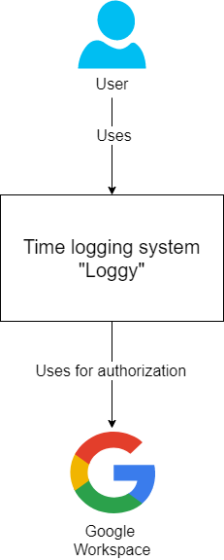

External interactions
- Google Workspace (former G-Suite) will be responsible for providing authentication to the system. Google user id tokens will be bound to users and used to uniquely identify resources in the system that belong to a specific system user.

Functional View
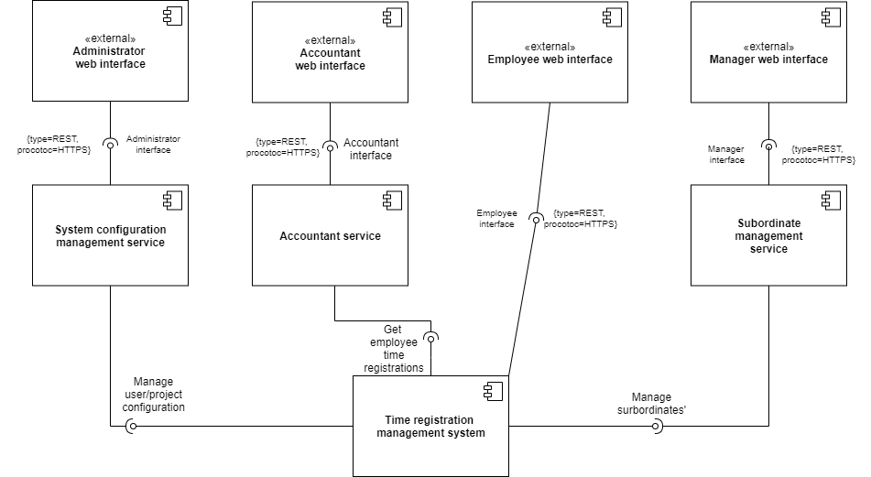

Functional Elements

Element Name | Description
Time registration management system | Entry point of the system, from employees perspective
System configuration management service | A service that enables administrator to assign roles to users, manage projects, project structure.
Accountant service | A service that enables accountant to view employee time registrations and export that data in selected format.
Subordinate management system | A service that enables managers to view subordinates’ time registrations and to approve/reject subordinate timesheets.
Administrator web interface | A collection of single page application windows, that administrator can interact with.
Accountant web interface | A collection of single page application windows, that accountant can interact with.
Employee web interface | A collection of single page application windows, that employee can interact with.
Manager web interface | A collection of single page application windows, that manager can interact with.

Information View

Data Structure
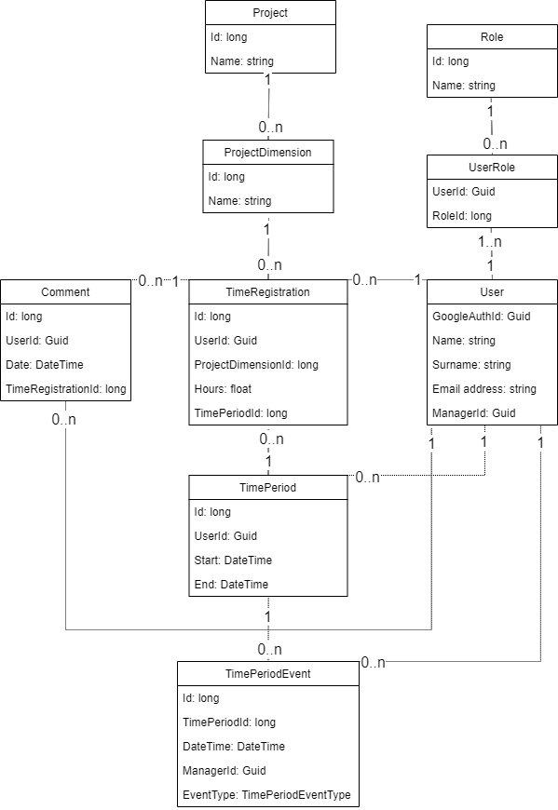

Data Flow
Time registration
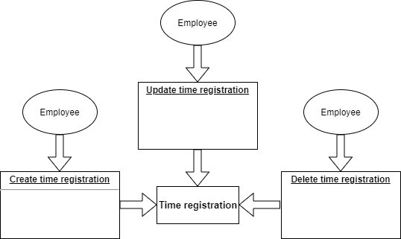

Project
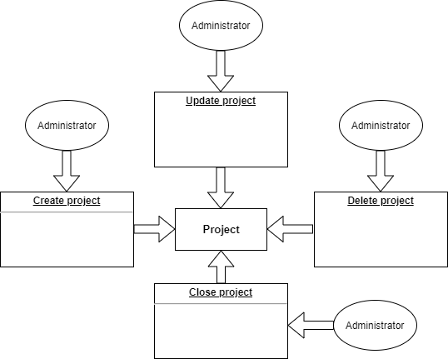

Time period
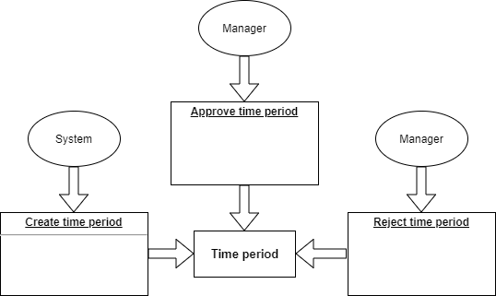

Data Ownership

Entity | Employee service | Accountant service | Administrator service | Manager service
Time registration | master | reader | none | reader
Time period | reader | none | none | writer (only statuses)
Project | reader | reader | master | reader
Project dimension | reader | reader | master | reader

Information Lifecycles
Time registration
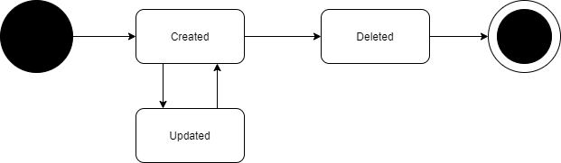

Project
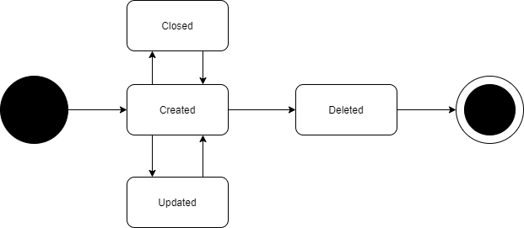

Deployment View

Runtime Platform Model

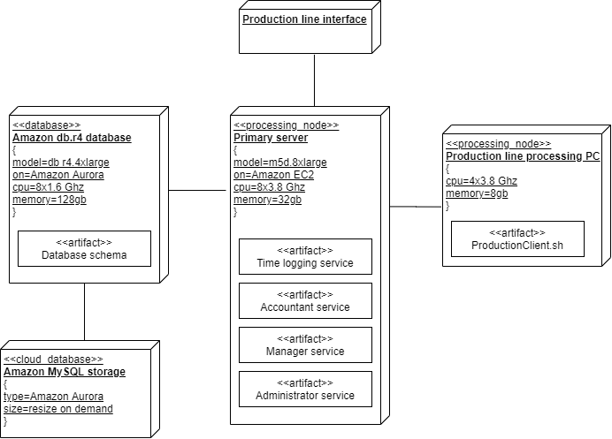

Network Model

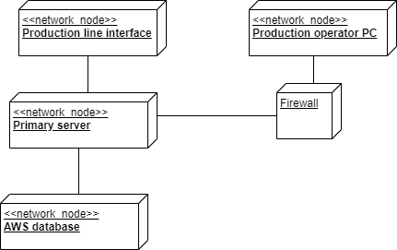

Development View

Module Structure

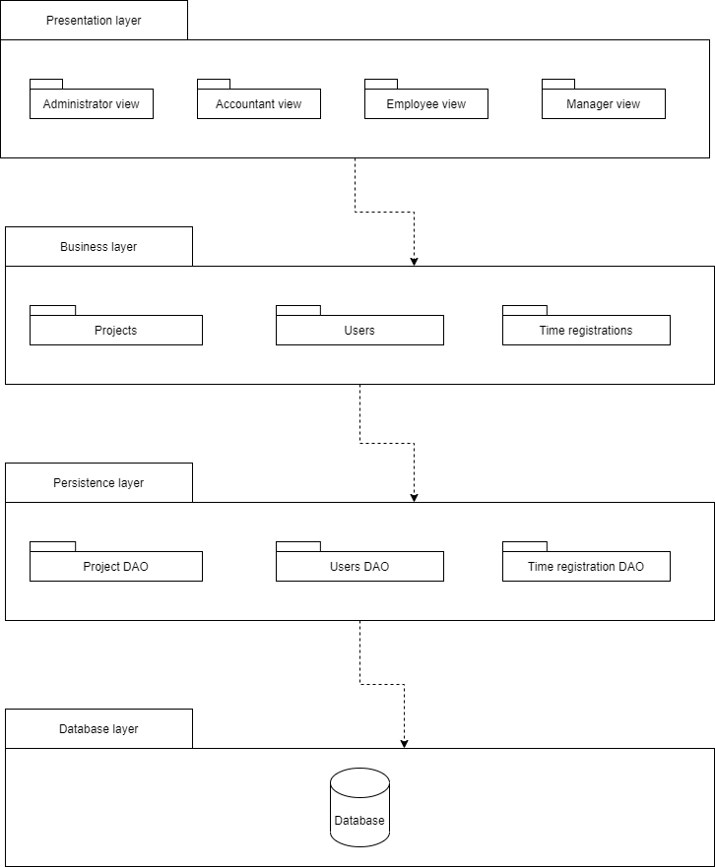

Common Design
- Presentation layer views are Angular templates that render information loaded from business layer services
- Business layer services, manipulate or return data from persistence layer using .NET Core
- Entity Framework Core is used for managing data access objects
- Business layer services can inject each other to use one another whenever needed
- All logging is done using native .NET Core logging interface and the logs will be send to Graylog.

Standards for Design, Code and Test

https://en.wikipedia.org/wiki/SOLID
https://en.wikipedia.org/wiki/KISS_principle
https://en.wikipedia.org/wiki/You_aren%27t_gonna_need_it
https://docs.telerik.com/devtools/justmock/basic-usage/arrange-act-assert
https://en.wikipedia.org/wiki/Design_Patterns

Codeline Organisation
- Code is separated according to purpose – related code is put into projects/folders/modules.
- Environments are (deployed in this order as well): development, acceptance, staging and production.
- Backend code is divided into projects, frontend code is divided into modules (following best Angular practises).
- Source code will be developed and deployed on a local machine for development and local testing purposes.
- Non local builds will be build in TeamCity, whenever the code is merged after the pull request.
- Unit tests is run during deployment stages, if a single test fails – the deployment fails as well.
- Source code will be stored inside GitHub repositories.
- Deployment to acceptance and staging environments will be setted up to run automatically, but the production step will also require an approval.

Operational View

Installation and Migration
The system is deployed to the AWS server and AWS Aurora database. These steps taken during update processes during deployment:
- Disable manipulation of data in service being updated
- Schedule update (notify users)
- Deploy artifacts
- Re-enable service data manipulation
A rollback can be done manually by deploying the old version of the build.
The deployment process needs to be confirmed before the deployment to production step by authorized personnel and from there it goes automatically.
A rollback may be performed on the database using available AWS Aurora functionality to target old database backup.

System Administration
System is monitored using AWS Cloudwatch service and Production line interface – AWS console.
Facility | Description
AWS Cloudwatch monitoring dashboards and logs | Administrators / support has access to AWS cloudwatch logs and dashboards to inspect system state, current load and error rate.
Production line interface | A dedicated administrator has access production interface (inside AWS Console) to inform parties of system malfunctions and try to restore system functionality.

AWS Cloudwatch alerts (setted up manually and routinely done by AWS cloudwatch):
- Database high CPU load (>75% CPU load)
- Database low storage (>85% storage left)
- Main server high CPU load (>75% CPU load)
If a service has stopped working and cannot be restarted:
- Notify responsible people through setted up communication channels (email, slack, sms, etc.).
- Use the production line interface (AWS console) to check for possible errors, that could be manually repaired.
- Redeploy.

Provision of Support
Support is provided on a 24/7 basis by dedicated teams of personnel.
The table below lists support level roles and responsibilities for the system:
Support level | Description
L0 | Administrative or customer support
L1 | Short-notice notification of responsible personnel
L2 | Immediate notification of responsible personnel, system monitoring and reaction to any related errors
L3 | Immediate notification of all related personnel, responsible for restoring system functionality as soon as possible

Issues based on criticality are assigned appropriate support level people
Incident criticality | Support level
Minor (Negligible) | L0
Minor (functionality retained) | L0
Medium (functionality retained, but impaired) | L1
High (partial loss of functionality) | L2
High (complete loss of functionality) | L2
Extreme (service down) | L3
Extreme (system down) | L3

